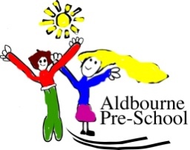
Aldbourne Preschool
Back Lane, Aldbourne, Marlborough, Wiltshire SN8 2BP Telephone: 01672 541648
Email: aldournepreschool@gmail.com
Web: www.aldbournepreschool.com

Policy: Alcohol
Issue Date | Review Date | Document Owner(s) | Approved
June 2018 | June 2021 | Cleo Jerram | Julie Kent

This policy has been drawn up by the staff of the Preschool, in consultation with the Owners and parents.
The Pre-School recognise the potential dangers of looking after children while under the influence of alcohol. To ensure the safety of our children we will not hand them over to parents or guardians if we believe that they have been drinking.

In the event of alcohol being smelt on the breath or behaviour which may suggest alcohol has been consumed by the parent or guardian, the child will not be handed over and the staff should contact another person indicated on the Registration Form to pick up the child

